**Lab 11:**

**Microsoft PowerPoint Overview**



When you start MS PowerPoint, it displays the Title Slide in the Slide pane. You can type the title of your presentation and a subtitle on this side. To enter text on the Title Slide:

1. Click and type the title of your presentation in the “Click to Add Title” area.
2. Click and type a subtitle in the “Click and Add Subtitle” area.

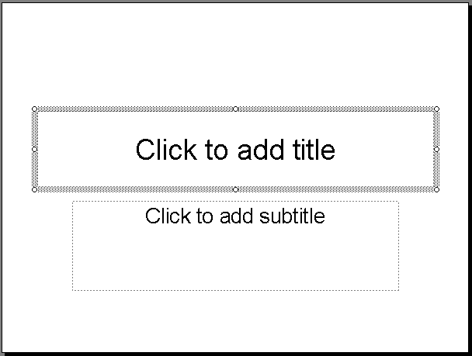

**Subtitle Area**

**Title Area**

Figure 3.2.1. The Title and Subtitle Area

If you do not wish to use the Title Slide, choose *Edit > Delete* *Slide* from the menu to delete it.

**Vista_icons_03Creating a New Slides**

After completing your tile slide, you can create additional slides. To create a new slide:

1. Do one of the following:

* Choose *Insert > New Slide* from the menu. MS PowerPoint inserts a new slide.
* Click the New Slide icon .
* Press Ctrl + M.

The “Apply Slide Layout” pane will appear on the right side of the screen. The Apply Slide Layout pane provides you with slide templates you can use when creating your MS PowerPoint presentation. There are four types of Text Layout Templates, see the following figure for example:

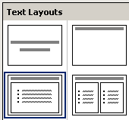

**Title and 2-Column Text**

**Title and Text**

**Title Only**

**Title**

Figure 3.2.2. The Four Text Layouts in MS PowerPoint

***Title Slide*** - The Title Slide contains two text placeholders that you can use to display a title and a subtitle of your presentation.

***Title Only*** - The Title Only slide contains a single placeholder. You can use it to display a title.

***Title and Text*** - The Title and Text template provides a placeholder for a title and a placeholder for text.

***Title and 2-Column Text*** - The Title and Text template provides a placeholder for a title and two placeholders for text.

1. To select a layout, click the Layout you want to apply in the Apply Slide Layout pane. The layout will then appear in the Slide pane. See the following figure for example:

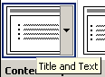

Figure 3.2.3. Choosing a Layout in Apply Layout Slide pane.

1. To add text, click inside the placeholder and type.
2. To add an additional slide to your presentation do one of the following:
   * Right-click on the slide layout. A menu will appear. Choose *Insert New Slide*.

* Click the Down Arrow next to the slide layout. A menu will appear. Choose *Insert New Slide*.

**Vista_icons_03Changing Your Slides**

After creating a slide, if you want to add text:

1. Place the cursor at the point at which you would like to add text.
2. Type the information you want to add.

If you would like to change text:

1. Highlight the text you want to change.
2. Type the new text.

You can use the Backspace key to delete text. You can also delete text by highlighting the text and pressing the Delete key.

**Vista_icons_03Applying a Design Template**

Design Templates provide attractive backgrounds for your PowerPoint slides. To apply Design Templates:

1. Do one of the following:

* Choose *Format > Slide Design* from the menu.
* Click the Slide Design icon .

Design Templates will appear on the right side of the screen.

1. To apply a Design Template to all of the slides in your presentation do one of the following:

* Click on the design template.
* Right-click on the template. A menu will appear. Choose *Apply to All Slides*.
* Click on the Down Arrow next to the template. A menu will appear. Choose *Apply to All Slides*.

See the following figure for example:

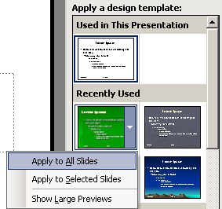

Figure 3.2.4. The Design Template

**Vista_icons_03Correcting a Spelling**

Using the PowerPoint Spell Checker, you can check the spelling in your PowerPoint documents. The following procedure demonstrates:

To start Spell Check, do one of the following:

* Choose *Tools > Spelling* from the menu.
* Press F7.
* Click the Spell Check icon .

If there are possible spelling errors, the Spelling dialog box will open.

|  |  |
| --- | --- |
| **Task** | **Procedure** |
| Do not change spelling. | Click *Ignore.* |
| Correct spelling. | 1. Click the correct spelling in the *Suggestions* box. 2. Click *Change*. |
| Add to Dictionary. |  |
| Word is correct. Do not change document. | Click *Ignore All*. |
| Word is incorrect. Change entire document. | Click *Change All*. |

**Vista_icons_03Sorter View**

After you have created your PowerPoint slides, you can move, cut, copy, paste, duplicate, navigate, and view them in Sorter view. To view the slides in Sorter view, do one of the following:

* Choose *View > Slide Sorter* from the menu.
* Click the Slide Sorter View icon.

See the following figure for example:

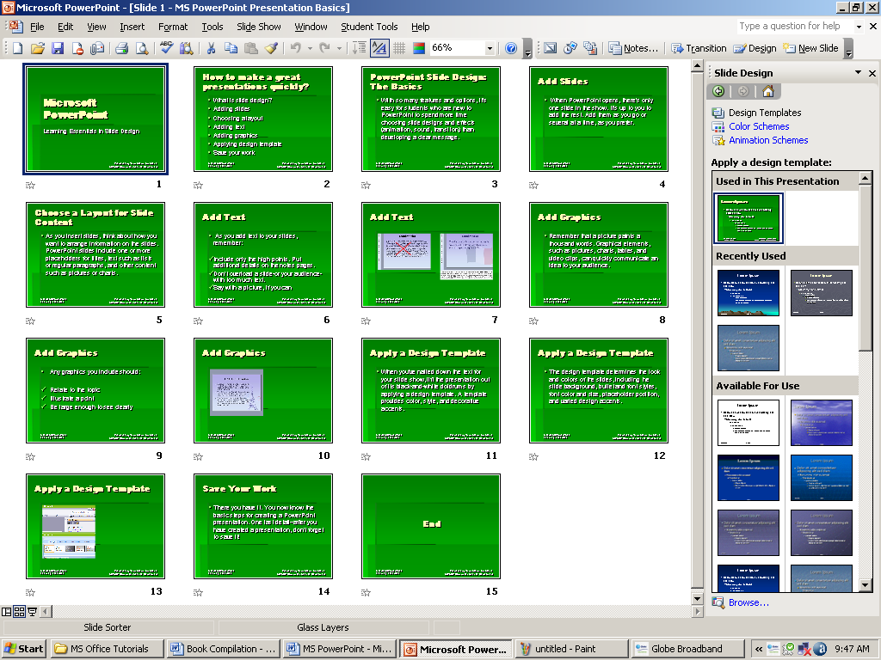

Figure 3.2.4. The Slide Sorted View.

|  |  |
| --- | --- |
| **Slide Sorter View** | |
| **Task** | **Procedure** |
| Move to first slide. | Ctrl – Home |
| Move to last slide. | Ctrl – End |
| Move to next slide. | Right Arrow |
| Move to previous slide. | Left Arrow |
| Select a slide. | Single-click slide. |
| Open slide in Normal view. | Double-click slide. |
| Select slides. | Select a single slides:   1. Click the slide you want to click.   Select multiple slides.   1. Hold down Ctrl key. 2. Click the slides you want to select. |
| Delete a slide. | 1. Select the slide or slides you want to delete. 2. Press the Delete key.   Or   1. Select the slide or slides you want to delete. 2. Choose *Edit > Delete Slide* from the menu. |
| Copy a slide. | 1. Select the slide. 2. Choose *Edit > Copy* from the menu.   Or   1. Select the slide. 2. Click the Copy icon.   Or   1. Select the slide. 2. Press Ctrl – C. |
| Paste a slide. | 1. Select a slide after which you want the new slide of slides to appear. 2. Choose *Edit > Paste* from the menu.   Or   1. Select the slide after which you want the new slide or slides to appear. 2. Click the Paste icon.   Or   1. Select the slide after which you want the new slide or slides appear. 2. Press Ctrl – V. |
| Cut a slide. | 1. Select the slide or slides you want to cut. 2. Choose *Edit > Cut* from the menu.   Or   1. Select the slide or slides you want to cut. 2. Click the Cut icon.   Or   1. Select the slide or slides you want to cut. 2. Press Ctrl – X. |
| Move a slide. | 1. Select the slide or slides you want to move. 2. Drag to the new location. |
| Duplicate a slide. | 1. Select the slide or slides you want to duplicate. 2. Choose *Edit > Duplicate* from the menu.   Or   1. Select the slide or slides you want to duplicate. 2. Press Ctrl – D. |

**Vista_icons_03Running your PowerPoint Presentations**

Once you have created your slides, you can run your Slide Show. Do any of the following:

* Press F5.
* Choose *Slide Show > View Show* from the menu.
* Click the Slide Show icon , which is located in the bottom left corner of your screen. Your slide will appear on your screen.

|  |  |
| --- | --- |
| **Navigating the Slide Show** | |
| **Task** | **Procedure** |
| Go to the next slide. | Do one of the following:   * Press the Right Arrow key. * Press the Enter key. * Press the Page Down key. * Left-click. |
| Go to the previous slide. | Do one of the following:   * Press the Left Arrow key. * Press the Backspace key. * Press the Page Up key. |

**Vista_icons_03Printing Your Slides**

PowerPoint provides you with many printing options. You can print a large view of your slides or you can print your slides as handouts with 1, 2, 3, 4, 6, or 9 slides per page. You can also print your Notes pages or Outline view of your slides.

To print:

1. Choose *File > Print Preview* from the menu. The Print Preview area will open.
2. Click the Down Arrow next to the Print What field.
3. Select what you would like to print.
4. Click the Print icon. The Print dialog box will open.
5. Select whether you want your slides to print in color, grayscale, or black and white. If you are using a black and white printer, choose black and white. You will use less ink or toner.
6. Check whether you want your slides to print vertically or horizontally.

**Lab 12:**

**Lesson 3. Creating Your First PowerPoint Presentation**

****

The following practice exercise steps you through your first PowerPoint presentation.

**Vista_icons_03Creating a Title Slide**

1. Start a new MS PowerPoint document.
2. Choose Blank Presentation on the Task pane. You will be presented with a Title slide. See the following figure for example:

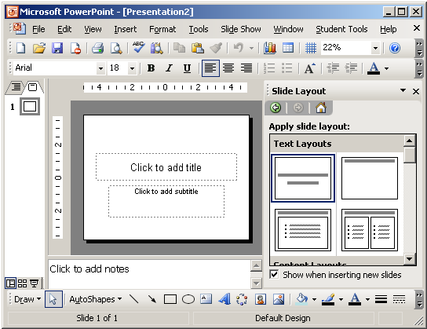

Figure 3.3.1. The New MS PowerPoint Presentation

1. Enter the information shown on the following figure below. Type “College Scholarships and Financial Aid” in the Click to Add Title text box. Type “Paying for College” in the Click to Add Subtitle text box.



Figure 3.3.2. Example Data in Title Slide

**Vista_icons_03Inserting a New Slide**

To insert new slide in MS PowerPoint, the following steps demonstrate:

1. Click the New Slide icon .
2. Click the Title and Text icon in Text Layout window on the left side of your screen. See the following figure for example:

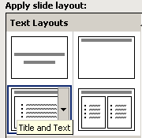

Figure 3.3.3. The Title and Text Layout

1. Enter the information shown in the following figure. Type “Here is what to do:” in the Click to Add Title area. Type the bulleted text in the Click to Add Text Area. See the following figure:



Figure 3.3.4. The Second Slide Text

**Vista_icons_03Creating a Hierarchy**

The following steps demonstrate.

1. Insert a new slide. Right-click the Title and Text icon. A context menu will appear. *Choose Insert New Slide* from the context menu.
2. Enter the information shown on the following figure below. Click the Increase Indent icon  to indent the bullets for Stafford Loan and PLUS Loans. If you ever wanted to decrease the indent, use the Decrease Indent icon . See the following figure for example:



Figure 3.3.5. The Text Hierarchy

**Vista_icons_03Using Two-column Text**

To create a Two-column Text in MS PowerPoint, the following steps demonstrate:

1. Right-click the Title and 2-Column Text icon from the Text Layout. A context menu will appear. Choose *Insert New Slide*.
2. Enter the information show on the following figure below. Type the information in the appropriate column. See the following figure for example:

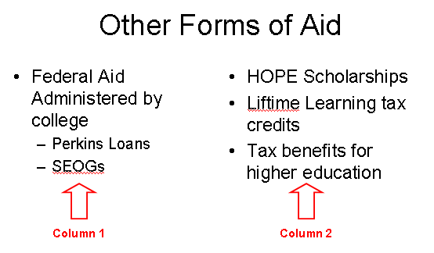

Figure 3.3.6. The Title and 2-Column Text Layout

**Vista_icons_03Applying a Design Template**

To apply Design Template in MS PowerPoint slides, the following steps demonstrate:

1. Click the Design icon . Design Templates will appear on the left side of the screen.
2. Scroll down to view the Design Templates.
3. Right-click the Design Template you want to apply. A context menu will appear. *Choose Apply to All Slides*. Used the *Glass Layer* design template. See the following figure for example:

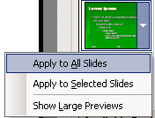

Figure 3.3.7. Selecting a Design Template

**Vista_icons_03Outline and Slides Tab**

The following steps demonstrate how to shift in Outline and Slides view:

1. Use the Slide tab to view thumbnails of your slide. See the following figure for example:

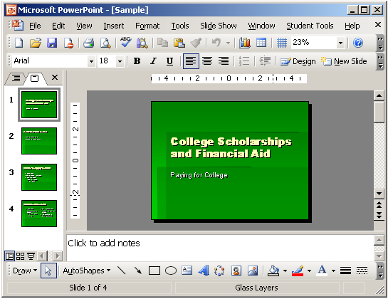

**Slide Tab**

Figure 3.3.8. The Slide View Tab

1. Click the Outline tab to view the text of your presentation as an outline. See the following figure for example:

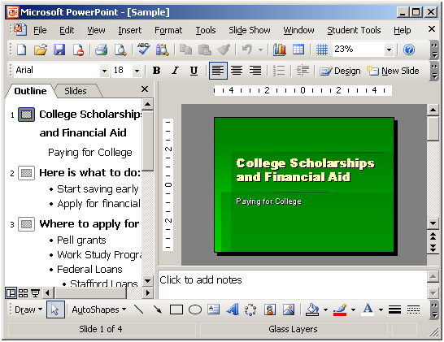

**Outline Tab**

Figure 3.3.9. The Outline View Tab

**Vista_icons_03The Slide Sorter View**

The following steps demonstrate the Slide Sorter View:

1. Choose *View > Slide Sorter* from the menu to move to Slide Sorter view. See the following figure for example:

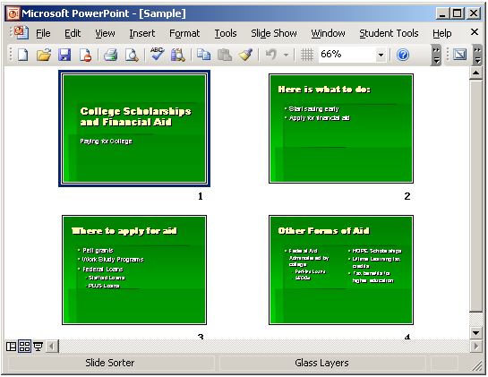

Figure 3.3.10. The Slide Sorter View

1. Double-click the slide to return to Normal view.

**Vista_icons_03Running Your Slide Show**

The following steps demonstrate the Slide Show view:

1. Press F5 key to run the Slide Show.
2. Use the arrow keys on your keyboard to move forward and backward through your slides.
3. Use Esc key to return to Normal view.

**Vista_icons_03Printing Your Outline**

1. Choose *File > Print Preview* from the menu.
2. Click the Down Arrow next to the Print What icon. See the following figure for example:

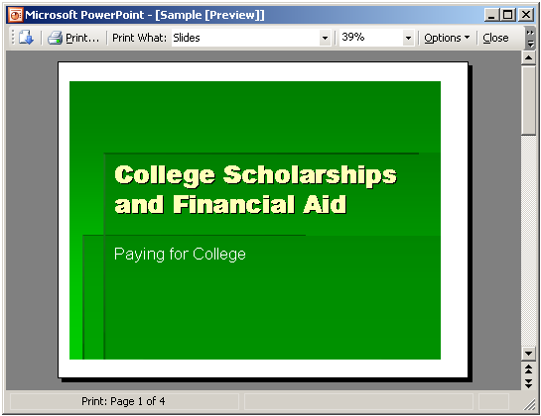

**Print What Icon**

Figure 3.3.11. Printing Outlines

1. Select Outline View.
2. Click the Print icon .
3. Click Close.

**Vista_icons_03Printing Your Slides**

1. Choose *File > Print Preview* from the menu.
2. Click the down arrow next to the Print What icon.
3. Select the slides you want to print.
4. Click the down arrow next to Options. A menu will appear.
5. Choose *Color/Grayscale > Pure Black and White*.
6. Click the Print icon.
7. Click Close.

**Vista_icons_03Printing Your Slides as Hand-out**

1. Choose *File > Print Preview* from the menu.
2. Click the down-arrow next to the Print What icon.
3. Select Handouts (2 Slides Per Page).
4. Click the Print icon.
5. Click Close.